7. ANSIBLE

Kubernetes probes
Probing means checking

Liveness probe = identify issue and reboot the pod
Self heal capacity present
A container is present in pod
If any thing happens and container get hanged or stuck
Liveness probe will identify and check if there is any deadlock restart it

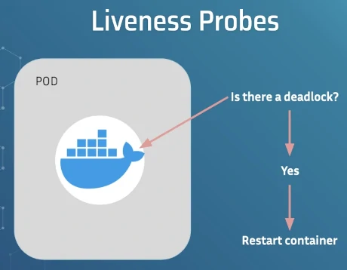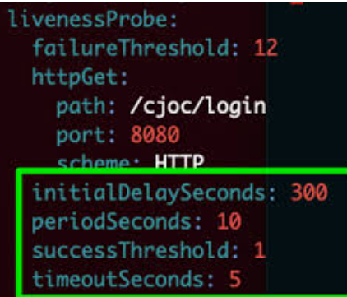

Path : endpoint of application
Port : port which it is running
Initial deploy seconds : the first time when liveness will test
Period seconds : regular interval after application startup
Success Threshold : The number of consecutive successful checks required for the container to be considered healthy.
Time out seconds : How long Azure waits for the application to respond before considering the check failed.

Readiness Probe : it will check whether pod is ready to receive traffic or not.
A readiness probe in Kubernetes is a mechanism used to determine whether container within a pod is ready to receive traffic and server requests.
It ensures that traffic is only routed to containers that have completed their installation and are fully prepared to handle incoming requests.
If pod gets hanged it will remove to a side to divert from request coming from load balancer until pod gets ready and again attaches to load balancer when it is ready.

Startup probe :
In a pod there is container, in container there is application,
This startup probe will check whether application is running or not
If app is running it will activate liveness probe and readiness probe
If app is not running it will deactivate liveness probe and readiness probe

ANSIBLE
Ansible/salt : works in push architecture
chef/puppet : works in pull architecture

ex : we are having 4 systems
in every system if we want to create tree service it is hectic
using ansible in one go we can do in all

for example we are having 1 master and 3 worker nodes
in master node we will create book and install tree
in worker nodes we will install chef agent
chef agent will check master node every time as is there any new packages
if found it will pull and install in worker nodes

in ansible server we don’t need any agent like chef
/etc/ansible
Ansible installment contains roles, hosts and ansible.cfg
Hosts : inventory
This inventory contains details of worker nodes

In ansible
Playbooks
It will be in yaml format
In playbooks we write scripts
Now this playbook execute in master node and
Push mechanism pushes the code to worker nodes and in worker nodes also this executes and installs

In ubuntu for creating a key : ssh-keygen
It is in the format of SHA256
Keep enter until key copied
For copying : ssh-copy-id <username>@<ipaddress or hostname>

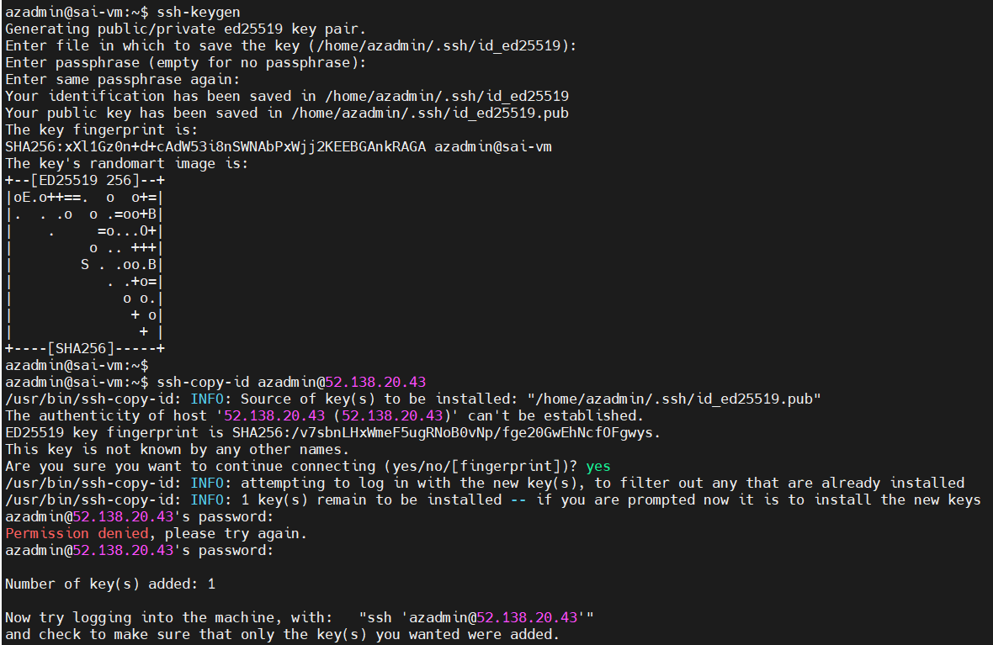

Now internally login to user account we don’t need password

ANSIBLE PRACTICAL

Update ubuntu : apt-get update
Upgrade ubuntu : apt-get upgrade -y
Both combined : apt-get update && apt-get upgrade -y

apt-get install software-properties-common
apt-add-repository ppa:ansible/ansible
Install Ansible : sudo-get apt install ansible -y

For this view use apt-get else it wont appears.
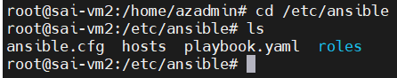

In hosts for editing ip address or dns names
For entering : vi hosts
For group declaration : [Sai]
For private ip : 10.0.1.1

For public
If key is password text : <ip> ansible_user=username ansible_password=password
Edit username and password according to vm

If key is file : <ip> ansible_user=azadmin ansible_ssh_private_key_file=~/.ssh/key.pem

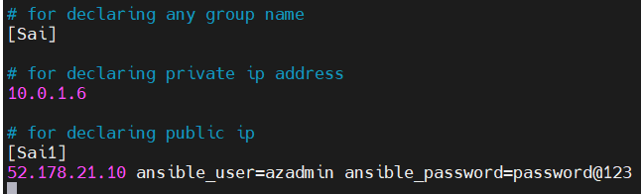

Username as ansible_user
Password as ansible_password

Result while showing ip as : ansible --list-host all
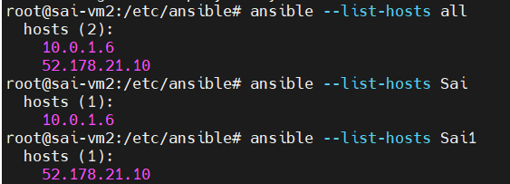

For disabling : export ANSIBLE_HOST_KEY_CHECKING=False
For connecting VM if public and having key as password
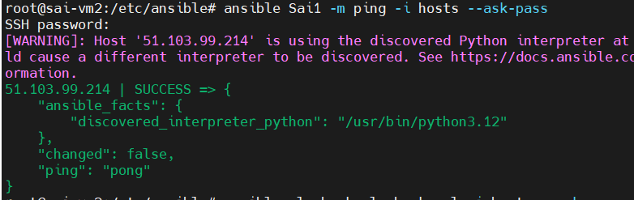

Ip login : ssh azadmin@51.103.99.214
It will ask:
Are you sure you want to continue connecting (yes/no)?
Type:
yes
This adds the server to:
~/.ssh/known_hosts
Now run Ansible again:
ansible web -m ping -i hosts --ask-pass
or
Edit Ansible config:
nano /etc/ansible/ansible.cfg
Find:
#host_key_checking = False
Change to:
host_key_checking = False

For version : ansible --version
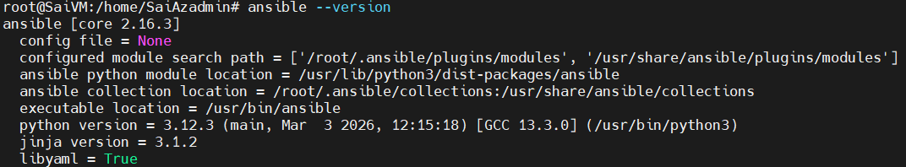

Ansible is configuration management tool
It is also a IAC
Idempodent : present infra will not touch, changes made in others

ansible-config init --disabled -t all > ansible.cfg

to view : cat ansible.cfg

to view and edit hosts and worker nodes : vi hosts
For hosts file : vi hosts

ansible --list-host all

in ansible we don’t use commands we use only modules

ansible website for documentation : https://docs.ansible.com/projects/ansible/latest/index.html

adhoc commands
it is used as commands but no history

ansible -m command -a “ls” ng1

ANSIBLE PLAY BOOKS

For version : ansible --version

For configuration changes we can configuration tool as ansible
For changing owner to ansible : sudo chown -R azadmin:azadmin ansible/
for listing : ls -l

for checking configuration file : cat ansible.cfg
for enabling it : ansible-config init --disabled -t all > ansible.cfg

host file is a inventory file

if you have any worker nodes
add ip in vi hosts file
as [groupname]
ip-address

Adhoc commands

In every command ng1 refer to worker node as converted name as dns or ip
to list out worker nodes in a group : ansible -m command -a “ls” ng1

ansible ng1 -m file -a “dest=/home/azadmin/new1 mode=777 owner=admin group=azadmin

for getting file info from node : ansible ng1 -m file -a “dest=/home/azadmin/new1 state=absent”

for checking file details of worker node from ansible : ansible ng1 -m shell -a ‘df -h /dev/sda1’ --home

complete info of worker node from ansible server with env : ansible ng1 -m setup

for installing nginx in worker node : ansible ng1 -m apt -a ‘name=nginx state=latest’ --become
state latest = latest version
started = start
stopped = stop
absent = uninstall
become = root permission true

for starting nginx in worker node : ansible all -m service -a ‘name=nginx state=started enabled=yes’ –become

for stopping service : ansible all -m service -a ‘name=nginx state=stopped’ --become

for getting worker node ansible details : ansible ng1 -m setup

: ansible ng1 -m apt -a ‘name=nginx state=absent purge=yes’ --become

In every command ng1 refer to worker node as converted name as dns or ip

For writing playbook : vi <name>yaml

Sample Playbook
1
---
-hosts: ng1 (worker node)
become= true ( it need to execute using root )
tasks:
- Name: task1 (any name )
debug:
msg: “hellotask1 executed”
- Name: task2 (any name )
debug:
msg: “hellotask2 executed”

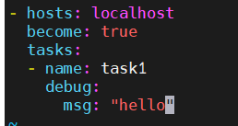

Code Explanation :
- hosts: ng1 → Run this playbook on the machine/group named ng1 (worker node).
become: true → Execute the tasks with root (sudo) privileges.
tasks: → Section where all tasks to execute are defined.
- name: task1 → Name/description of the first task (used for identification).
debug: → Ansible module used to print messages or variables.
msg: "hellotask1 executed" → Message that will be displayed when task1 runs.

for executing : ansible-playbook <playbookname>.yaml

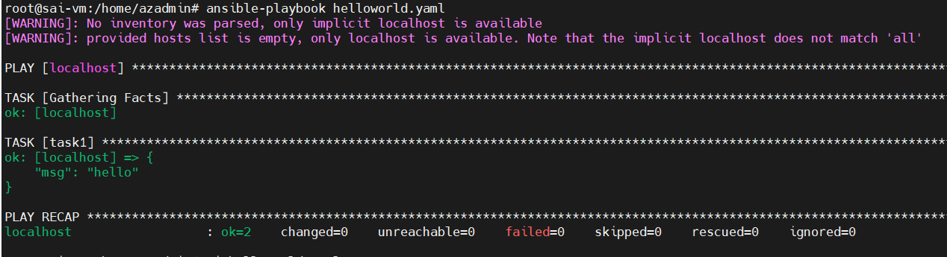

2nd playbook
---
-hosts: localhost
become: true
tasks:
- name: create directory
file: path=/home/azadmin/temp123 state=directory mode=775 owner=azadmin group=azadmin
---

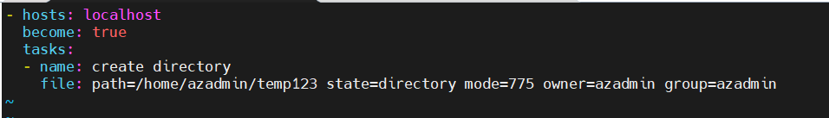

Code or File explanation :
- hosts: localhost → Run this playbook on the local machine where Ansible is installed.
become: true → Execute the task with root (sudo) privileges.
tasks: → Section where all operations/tasks are written.
- name: create directory → Name/description of the task.
file: → Ansible module used to manage files and directories.
path: → Location where the file or directory will be created.
/home/azadmin/temp123 → Directory path to be created.
state: directory → Tells Ansible to create a directory.
mode: 775 → Sets permissions of the directory (read/write/execute).
owner: azadmin → Sets azadmin as the owner of the directory.
group: azadmin → Sets azadmin group as the group owner.
--- → Indicates the start or separator of a YAML document.

2nd execution : ansible-playbook <filename>.yaml
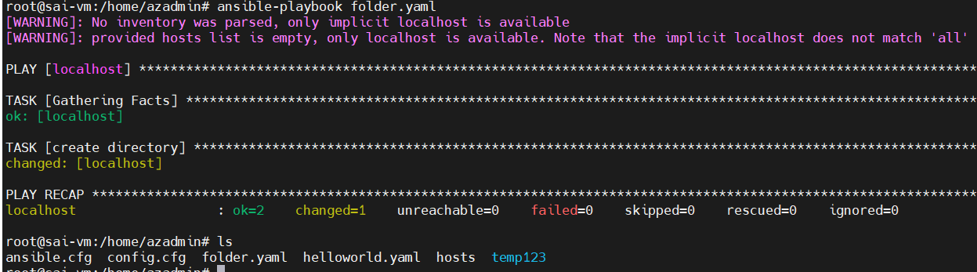

3rd file : copy content to file
---
-hosts: localhost
become: true
tasks:
- name: copy content to file
copy: content=”helloSai /n” dest=/home/azadmin/hello.txt
---
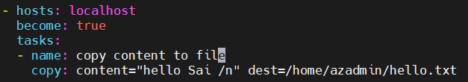

For execution : ansible-playbook <filename>.txt

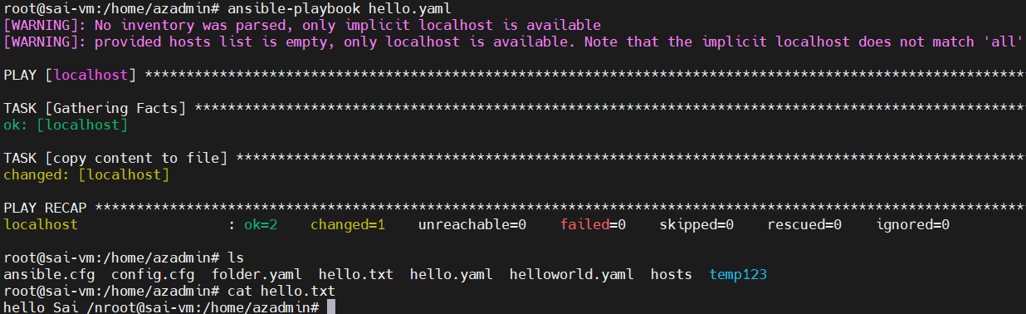

4th : installing tomcat
---
- name: Install Apache Tomcat
hosts: localhost
connection: local
become: yes
vars:
tomcat_url: https://archive.apache.org/dist/tomcat/tomcat-9/v9.0.85/bin/apache-tomcat-9.0.85.tar.gz
download_path: /tmp/tomcat.tar.gz
install_path: /home/azadmin

tasks:

- name: Task 1 - Download Tomcat
get_url:
url: "{{ tomcat_url }}"
dest: "{{ download_path }}"

- name: Task 2 - Extract Tomcat
unarchive:
src: "{{ download_path }}"
dest: "{{ install_path }}"
remote_src: yes

- name: Task 3 - Rename Tomcat directory
command: mv {{ install_path }}/apache-tomcat-9.0.85 {{ install_path }}/tomcat
args:
creates: "{{ install_path }}/tomcat"

- name: Task 4 - Set ownership and permissions
file:
path: "{{ install_path }}/tomcat"
state: directory
owner: azadmin
group: azadmin
mode: '0775'
recurse: yes
---

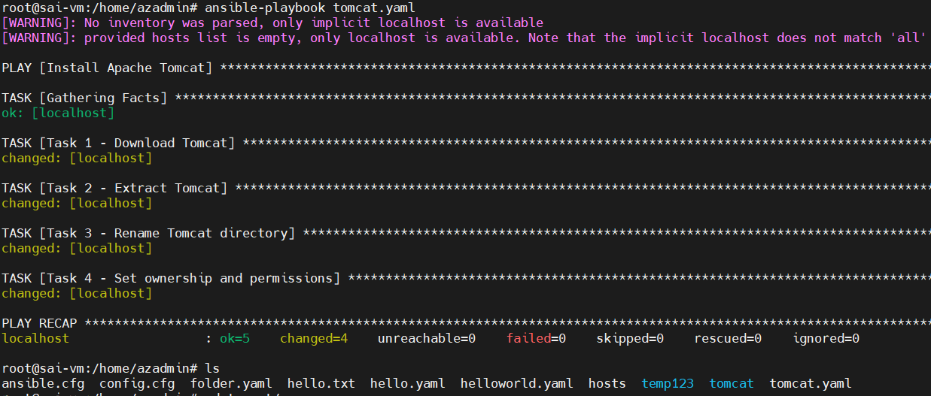

--- → Indicates the start of a YAML playbook document.
name: → Description of the play or task.
Install Apache Tomcat → Title of the playbook operation.
hosts: → Defines which machine the playbook will run on.
localhost → Means run on the local system where Ansible is installed.
connection: → Specifies how Ansible connects to the host.
local → Tells Ansible to run commands locally instead of SSH.
become: → Used to execute tasks with elevated (sudo/root) privileges.
yes → Enables privilege escalation (sudo).
vars: → Section used to define variables.
tomcat_url: → Variable storing Tomcat download URL.
download_path: → Variable storing location where the file will be downloaded.
install_path: → Variable storing directory where Tomcat will be installed.
tasks: → Section where all tasks to execute are written.

Task 1
Task 1 - Download Tomcat → Task description for downloading Tomcat.
get_url: → Ansible module used to download files from the internet.
url: → Specifies the source URL of the file.
{{ tomcat_url }} → Uses the variable value of the Tomcat download link.
dest: → Defines the destination path to save the downloaded file.
{{ download_path }} → Uses the variable path where Tomcat will be saved.

Task 2
Task 2 - Extract Tomcat → Task description for extracting the Tomcat archive.
unarchive: → Ansible module used to extract compressed files.
src: → Specifies the source archive file to extract.
dest: → Specifies the location where files will be extracted.
remote_src: → Tells Ansible the file already exists on the remote machine.
yes → Confirms source file is already present remotely.

Task 3
Task 3 - Rename Tomcat directory → Task description to rename the extracted folder.
command: → Ansible module used to run Linux commands.
mv → Linux command used to rename or move files/directories.
args: → Provides additional parameters for the module.
creates: → Prevents running the command if the target already exists.

Task 4
Task 4 - Set ownership and permissions → Task description for setting directory permissions.
file: → Ansible module used to manage files and directories.
path: → Specifies the directory whose properties will be modified.
state: → Defines the desired state of the file/directory.
directory → Ensures the path exists as a directory.
owner: → Sets the user who owns the directory.
group: → Sets the group ownership.
mode: → Defines file/directory permission settings.
0775 → Permission where owner/group have full access and others have read/execute.
recurse: → Applies ownership and permissions to all files inside the directory.
yes → Enables recursive permission changes

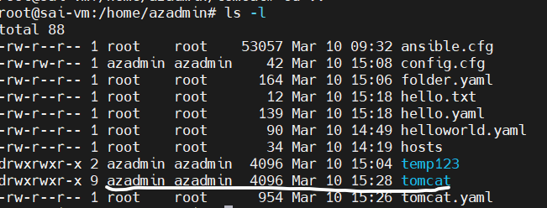

5 Variables :

---
- hosts: localhost
vars:
greeting: Hello Sai

tasks:
- name: Ansible Basic Variable
debug:
msg: "{{ greeting }}"
---

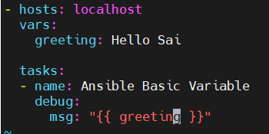

For exeution : ansible-playbook <file>.yml
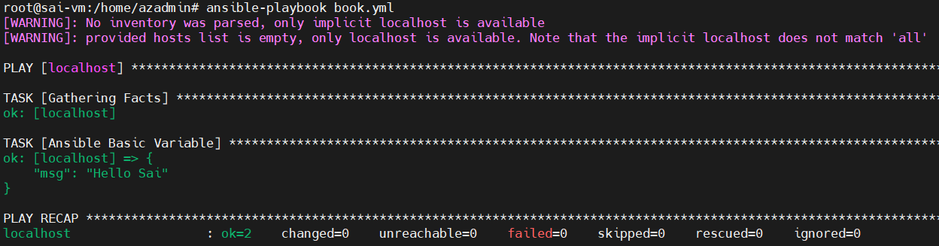

6 List
---
- hosts: localhost
vars:
continents:
- Africa
- Asia
- Europe

tasks:
- name: Ansible list
debug:
msg: "{{ continents }}"
---

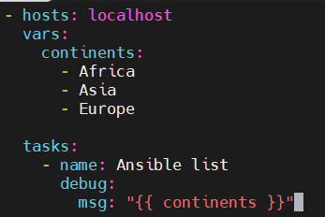

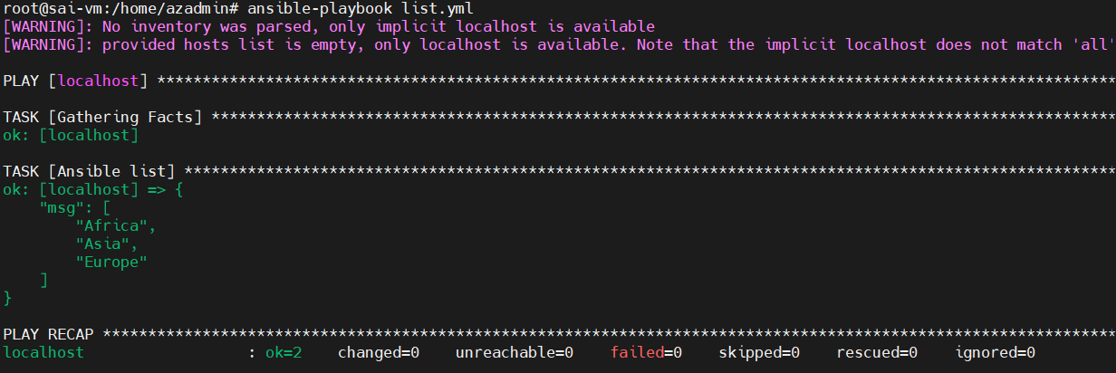

7 In list particular one
---
---
- hosts: localhost
vars:
continents:
- Africa
- Asia
- Europe

tasks:
- name: Ansible list
debug:
msg: "{{ continents [] }}"
---

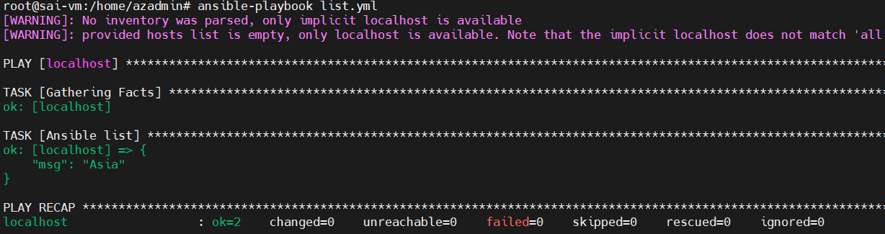

8 List with all
---
- hosts: localhost
connection: local
vars:
continents: [Africa, Asia, America]

tasks:
- name: List with all
debug:
msg: "{{ item }}"
with_items:
- "{{ continents }}"
---

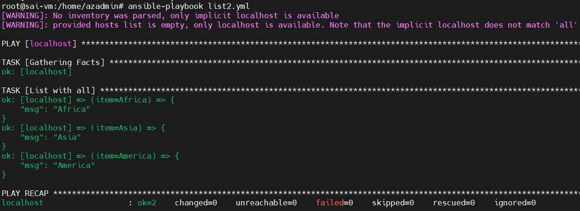

9. creating multiple files with permission
----
- hosts: localhost
tasks:
- name: Ansible creation of multiple files with permission
file:
path: "{{ items }}"
state: touch
mode: 0775
with_items:
- Sai.log
- Vcubesoft.txt
- devops.txt
---

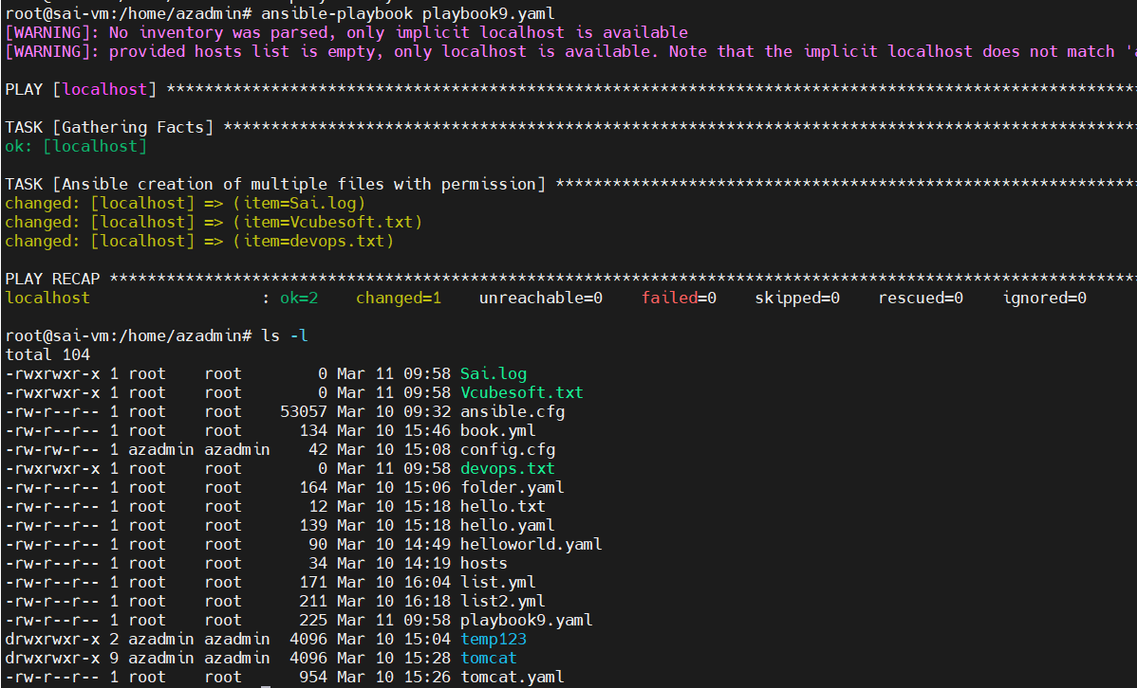

10. ansible loop example
- hosts: localhost
become: true
vars:
sw: [tree, git, maven]
tasks:
- name: Ansible Loop example
apt:
name: "{{item }}"
state: present
with_items: "{{ sw }}"

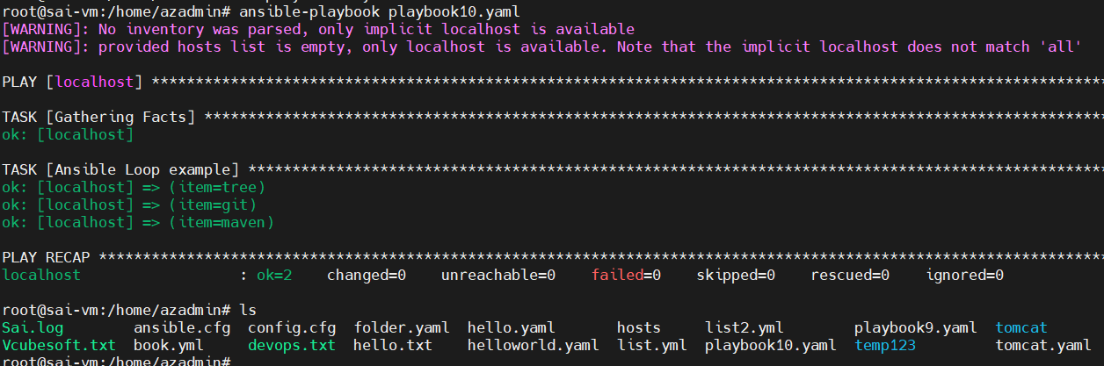

11.
-----
- hosts: localhost
become: true

tasks:
- name: Create multiple directories
file:
path: "{{ item }}"
state: directory
with_items:
- /home/azadmin/vn1
- /home/azadmin/vn2
- /home/azadmin/vn3
-------

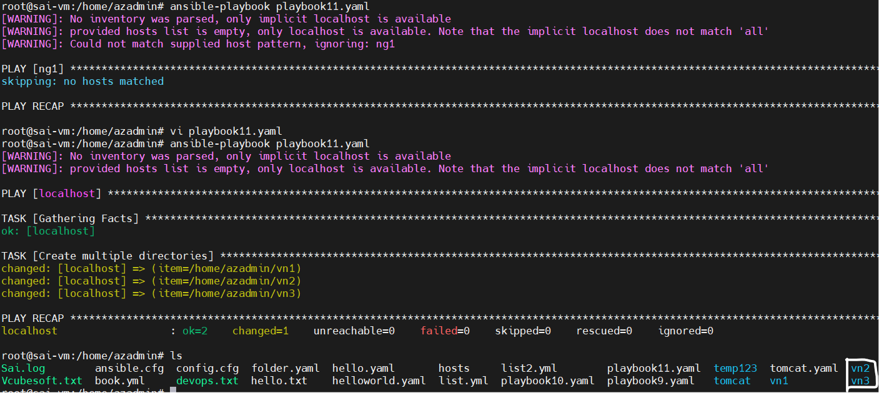

12.
----
- hosts: ng1
vars:
Tree:
k1: "v1"
k2: "v2"
k3: "v3"
tasks:
- name: Ansible dictionary variable example
debug:
msg: "{{ Tree.k1 }}"
----

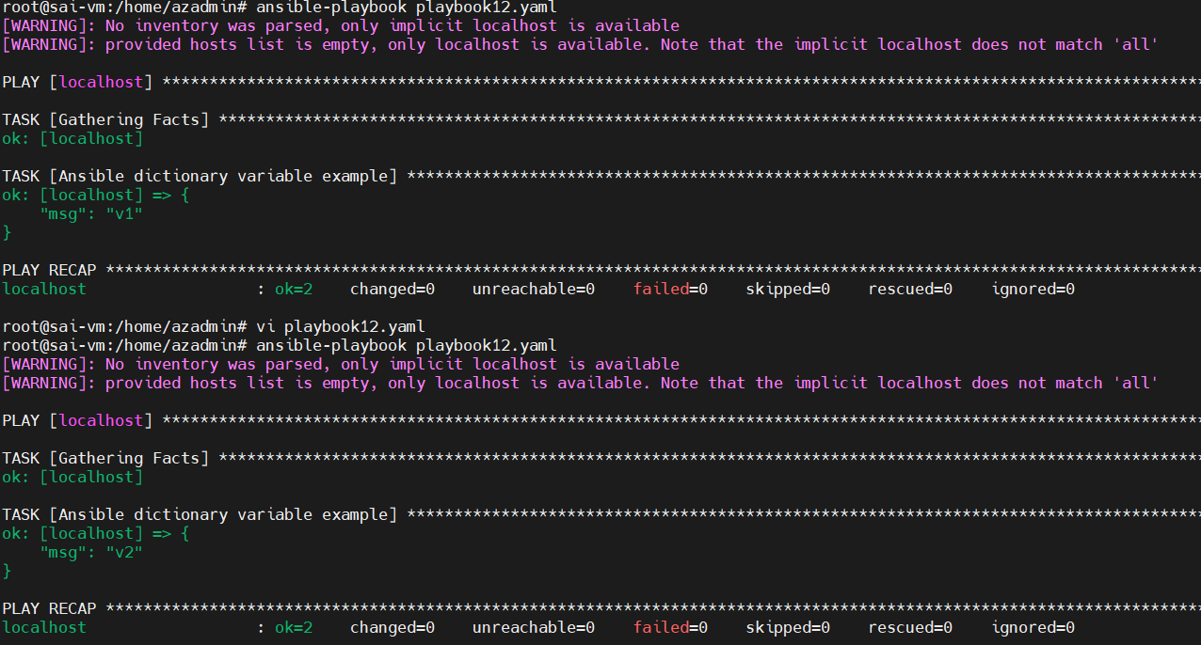

13.
------
- hosts: ng1
tasks:
- name: Ansible create multiple files example
file:
path: "{{ item.location }}"
state: touch
mode: "{{ item.mode }}"
with_items:
- { location: 'filek.txt', mode: '0566' }
- { location: 'fileg.txt', mode: '0766' }
-----------

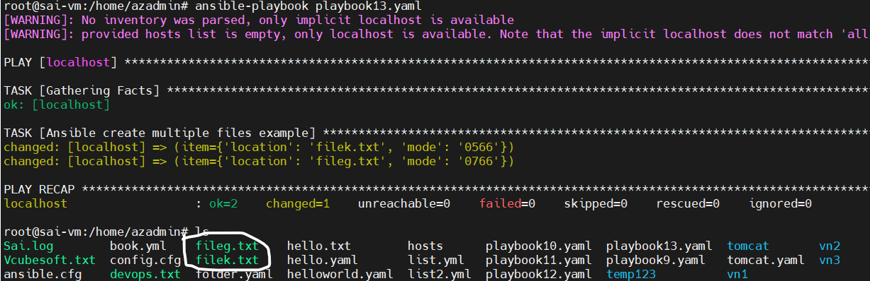

ANSIBLE ROLES

Task : to print ansible os family

---
- hosts: all
tasks:
- name: Ansible Basic Family
debug:
msg: {{ ansible_os_family}}
---
For self
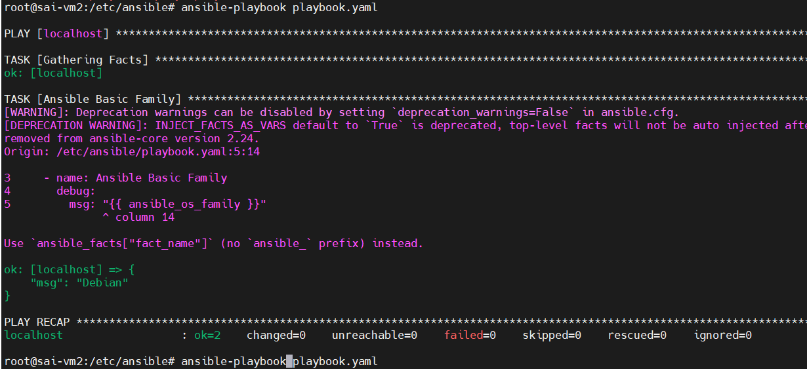
For worker node vm :

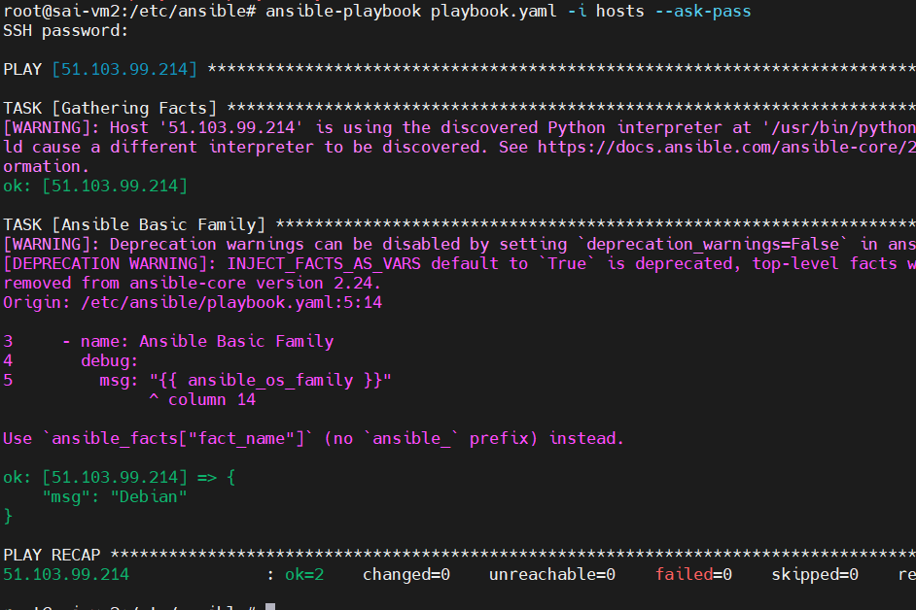

In yaml if we write
Ng1 as 100 servers
50 debian
50 rhel

Allservers does not get executed by yaml file
Though it is same linux due to different package manager as
Debian apt
Rhel yum

ANSIBLE ROLES

For showing complete details of worker nodes with predefined variables
: ansible -m setup all

playbook20 code
---
- hosts: all
tasks:
- name: Ansible basic Variable
debug:
msg: "{{ ansible_os_family }}"

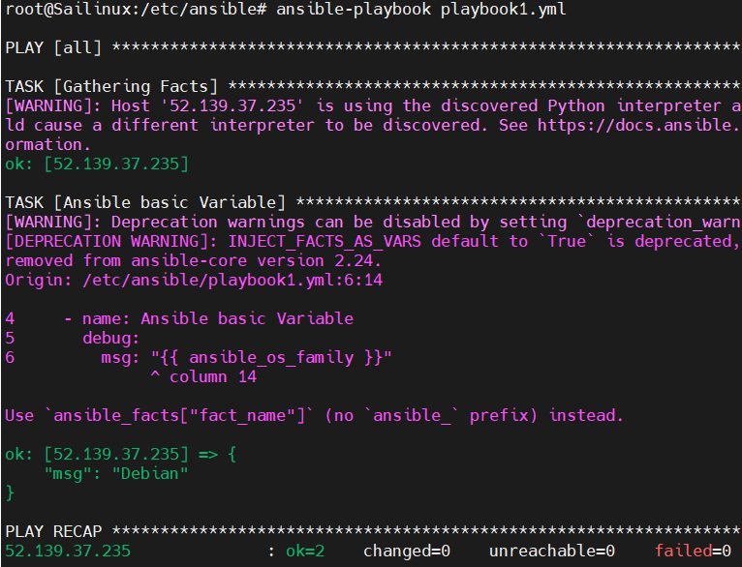

Playbook code 21
Condition based application install

---
- hosts: all
become: yes
tasks:

- name: Install Java on Debian based systems
apt:
name: default-jdk
state: present
update_cache: yes
when: ansible_os_family == "Debian"

- name: Install Java on RedHat systems
yum:
name: java-11-openjdk
state: present
when: ansible_os_family == "RedHat"

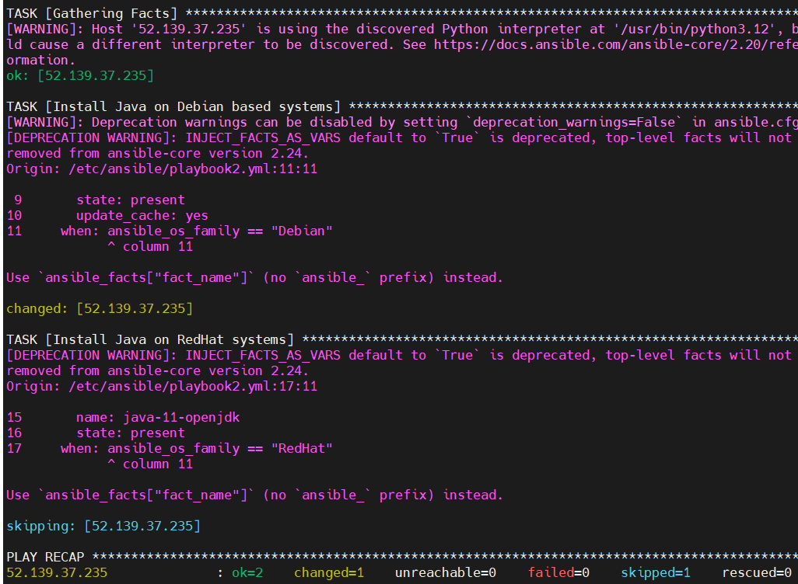

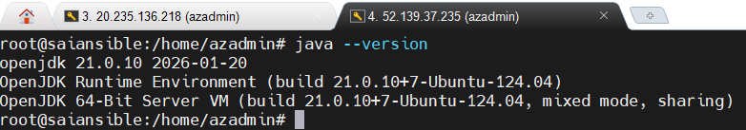

- for listing out tasks in yaml or yml files : ansible-playbook <filename.yml> --list-tasks

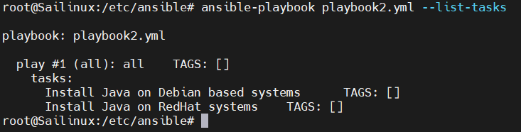

- Task based on tag

- hosts: all
become: yes
tasks:
- name: task1
debug:
msg: "task1 complete"
tags: task1
- name: task2
debug:
msg: "task2 complete"
tags: task2
- name: task3
debug:
msg: "task3 complete"
tags: task3

For executing all tasks : ansible-playbook <filename.yml>
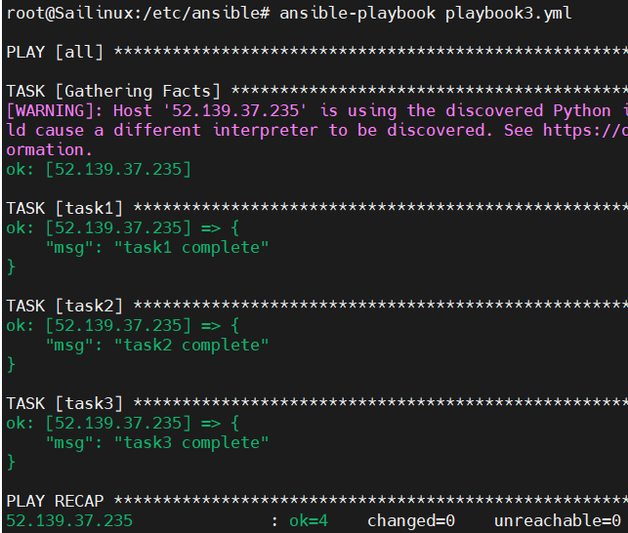

For executing selected tasks : ansible-playbook <filename.yml> --tags “tag”

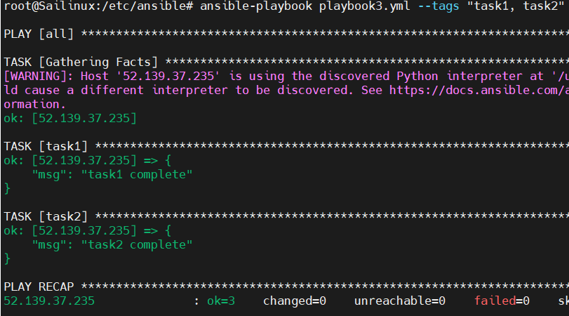

For executing tasks skiping which are not needed : ansible-playbook <filename.yml> --skip-tags “tag2”
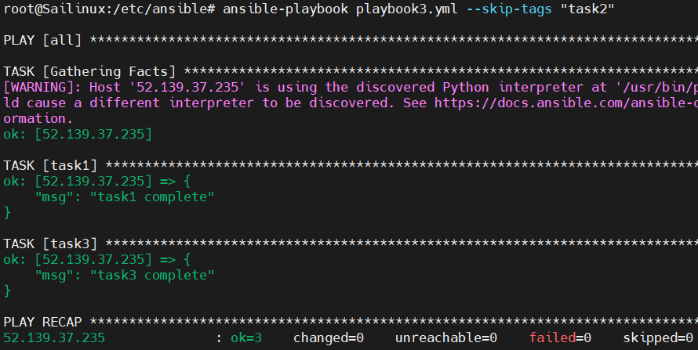

For listing all tasks : For executing all tasks : ansible-playbook <filename.yml> --list-tasks
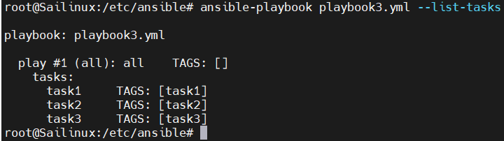

This playbook is used to install or uninstall an app
Use one tag for install and another tag for uninstall
Both in one file

- Ansible file for installing and uninstalling application in one file based on tags
- hosts: all
become: true
tasks:
- name: I am installing application
apt:
name: tree
state: present
tags: install
- name: i am uninstalling application
apt:
name: tree
state: absent
tags: uninstall

For application if you don’t provide any tags it will do both install and uninstall
: ansible:playbook <playbook.yml>
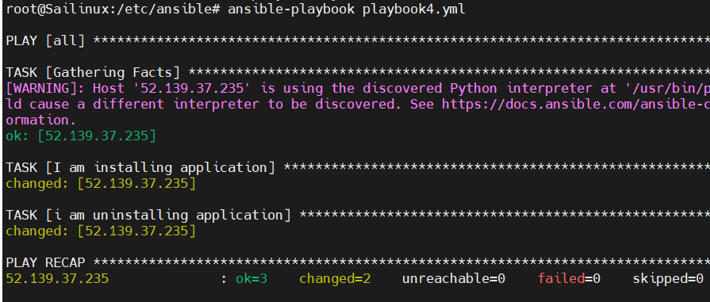

For installing application provide tag install : ansible:playbook <playbook.yml> --tags “install”
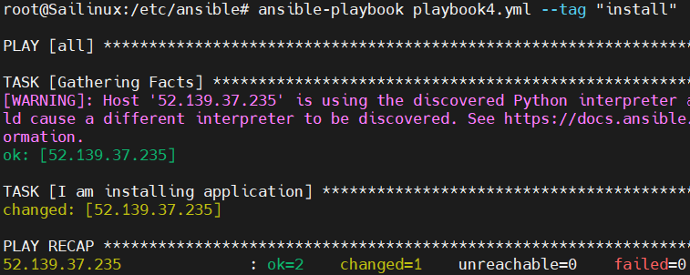

From worker node :
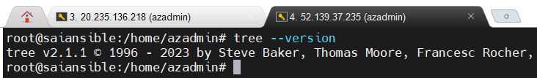

For uninstalling application provide tag uninstall : ansible:playbook <playbook.yml> --tags “uninstall”
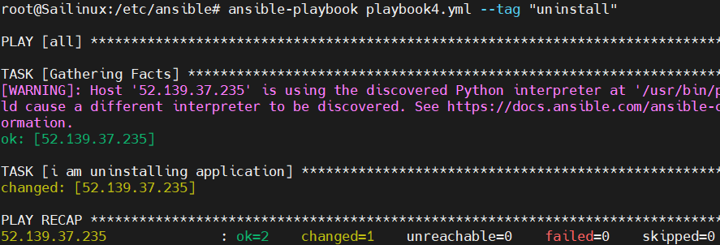

After uninstall in worker node :
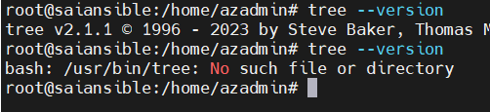

- Handler : it is a kind of notification
- It will only call when it is doing some changes on remote env
in worker node

- Simply : to get notified

When there is no change
---
- hosts: all
become: yes
gather_facts: no

tasks:
- name: task1
debug:
msg: "Hello Task 1 is executed"
notify: hd1

handlers:
- name: hd1
debug:
msg: "my hd1 is called!!!"

- Handler message not printed because no changes in worker node
If there is any changed it get notified

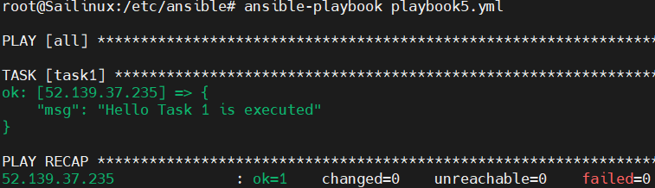

When there is change :

---

become: yes
gather_facts: no
tasks:
- name: Create a directory
file:
path: /home/azadmin/mydir
state: directory
owner: azadmin
group: azadmin
mode: '0755'
notify: myhd1
handlers:
- name: hd1
debug:
msg: “ my hd1 is calling”
become: yes

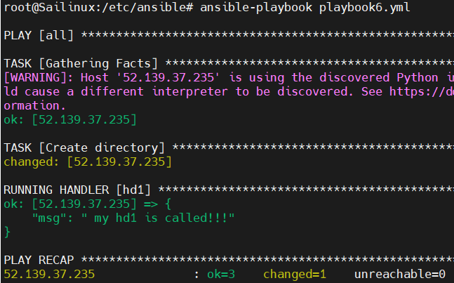

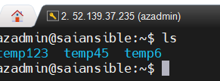

- Shell module :

. What is Shell Module?
- The shell module is used to run Linux shell commands on remote servers (managed nodes).
- It executes commands using the /bin/sh shell.

2. What is the Use?
- To execute commands or scripts on remote machines.
- To perform administration tasks automatically.

3. Why Do We Use It?
- When commands require shell features like:
  - Pipes (|)
  - Redirection (>, >>)
  - Multiple commands (&&)
  - Environment variables

4. Simple Example
- name: Check disk space
shell: df -h

5. Key Points
- Runs shell commands on remote nodes
- Supports pipes and redirection
- Used when command module cannot run complex shell commands
✅ Short interview answer:
- Shell module in Ansible is used to execute shell commands on remote hosts and is mainly used when commands require shell features like pipes, redirection, or multiple commands.

- Ansible Roles : it is similar like a modules
- Simply we create a module like to create a file or to create a directory or install app
- But modules don’t have values it just a raw code
- Once we want it or have requirement
- We just call module and pass values that’s it
- But we don’t write entire raw code again, just call it and pass values

For nginx role : ansible-galaxy init nginxrole
Install tree : apt-get install tree

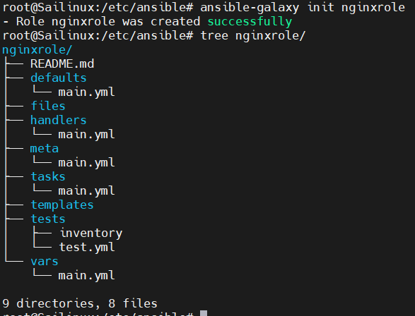

For changing : cd nginxrole/
For editing : vi tasks/install.yml

- name: installing nginx server
apt:
name: nginx
state: present

for editing : vi tasks/main.yml
#SPDX-License-Identifier: MIT-0
---
# tasks file for nginxrole

- include_tasks: install.yml

Now write playbook for install nginx
- hosts: all
become: true
roles:
- nginxrole

For execution : ansible-playbook <filename>.yml

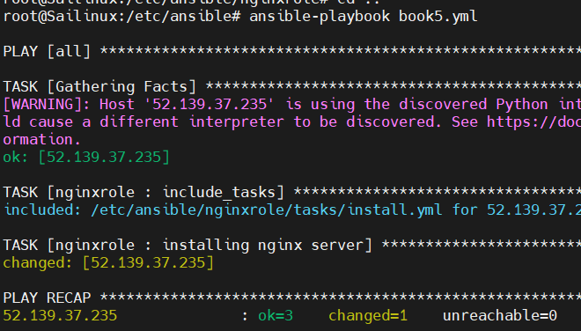

Ansible roles official web page : https://galaxy.ansible.com/ui/

Ansible configuration management tool
For worker nodes or group of servers we can create file directory
Install app

Ansible can be used to create infra but rare

